**Northeastern Illinois University**

## 19/06/2014

**Other UML Diagrams Document**

**Timesheet & Leave Management System**

#### Anusha Bestha

#### Jyoti Behera

#### Lakshmi Vasundhara Tammisetty

#### Sumanth Tadikonda

#### Sushma Adepu

Table of Contents

Class Diagram 4

Activity Diagrams 5

Module 0 – Student Worker Profile 5

*Activity Diagram 0* – Create Student Worker Profile 5

*Activity Diagram 1– View Student Worker Profile* 6

*Activity Diagram 2 – Edit Student Worker Profile* 7

*Activity Diagram 3 – Activate Student Worker Profile* 8

*Activity Diagram 4 – Deactivate Student Worker Profile* 9

Module 1– Login 10

*Activity Diagram 5 – Login* 10

*Activity Diagram 6 – Change password* 11

*Activity Diagram 7 – Forget Passowrd* 12

Module 2 & 4- Timesheets 13

*Activity Diagram 8*– Timesheet 13

Module 5 – Approve/Reject Leave Requests 13

*Activity Diagram 8 – Approve Leave Request* 13

*Activity Diagram 9 – Reject Leave Request* 14

Sequence Diagrams 15

Module 0 – Student worker Profile 15

*Sequence Diagram 0 – Manger* 15

*Sequence Diagram 1 – Student* 16

Module 1 – Login 17

Module 2 & 4– Tiemsheets 18

*Sequence Diagram –Timesheets* 15

Module 5 – Approve/Reject Leave Requests 18

DOCUMENT RELEASE NOTICE

**Document Details:**

|  |  |  |
| --- | --- | --- |
| **Name** | **Version No.** | **Description** |
| Other UML Diagrams Document | 0.1 | This document for **Timesheet & Leave Management System** Of **Northeastern Illinois University** includes the activity, sequence and class diagrams of all the modules. |

**Revision Details**

|  |  |  |  |
| --- | --- | --- | --- |
| **Action taken**  **(Add/Del/Change)** | **Preceding Page No.** | **New Page No.** | **Revision Description** |
|  |  |  |  |
|  |  |  |  |
|  |  |  |  |
|  |  |  |  |
|  |  |  |  |

# Class Diagram

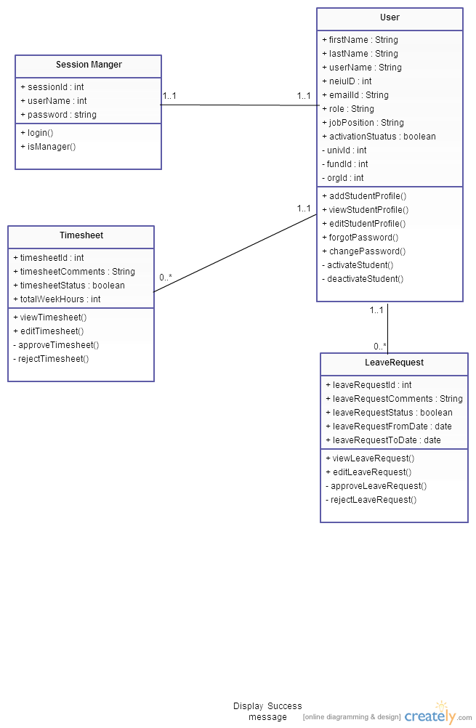

# Activity Diagrams

## Module 0 – Student Worker Profile

### Activity Diagram 0 – Create Student Worker Profile

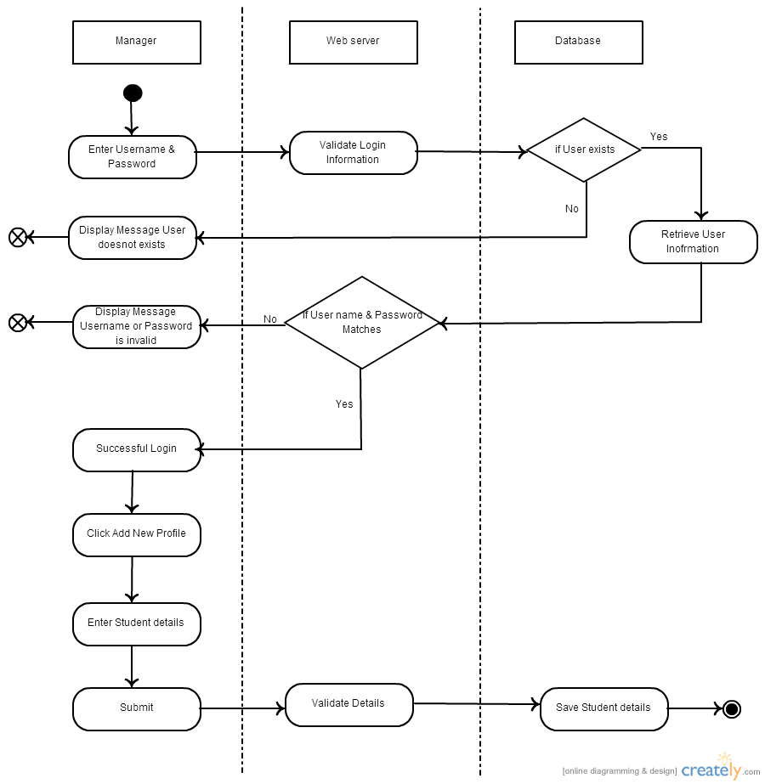

### Activity Diagram 1– View Student Worker Profile

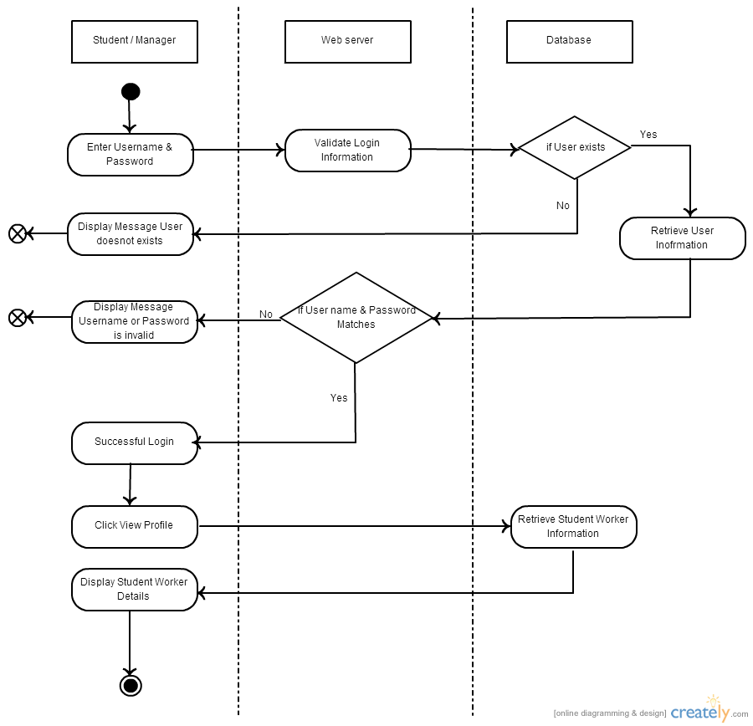

### Activity Diagram 2 – Edit Student Worker Profile

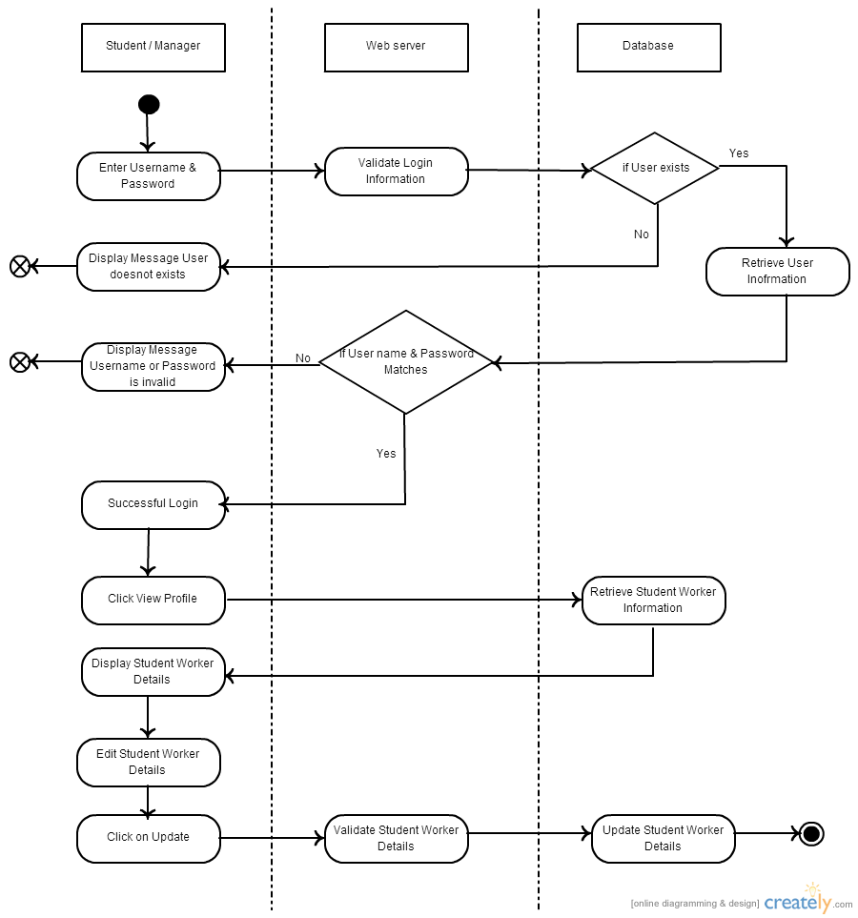

### Activity Diagram 3 – Activate Student Worker Profile

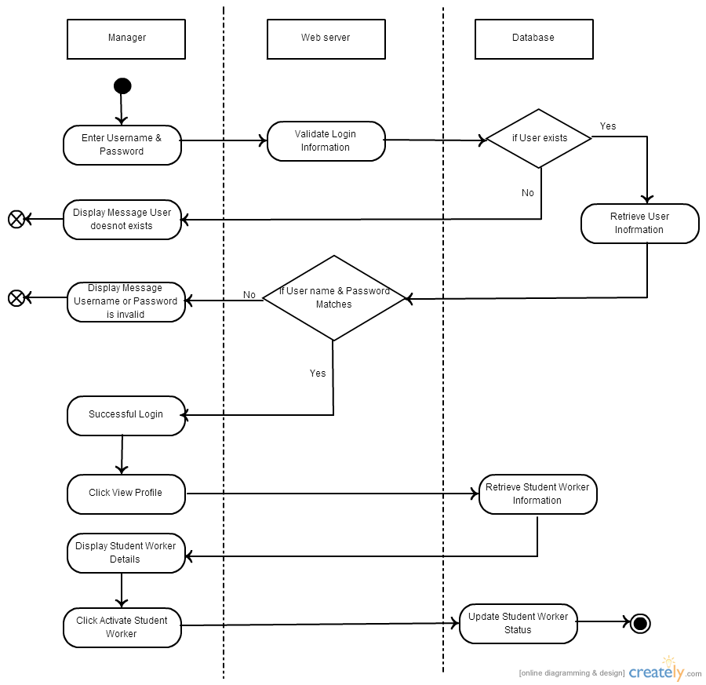

### Activity Diagram 4 – Deactivate Student Worker Profile

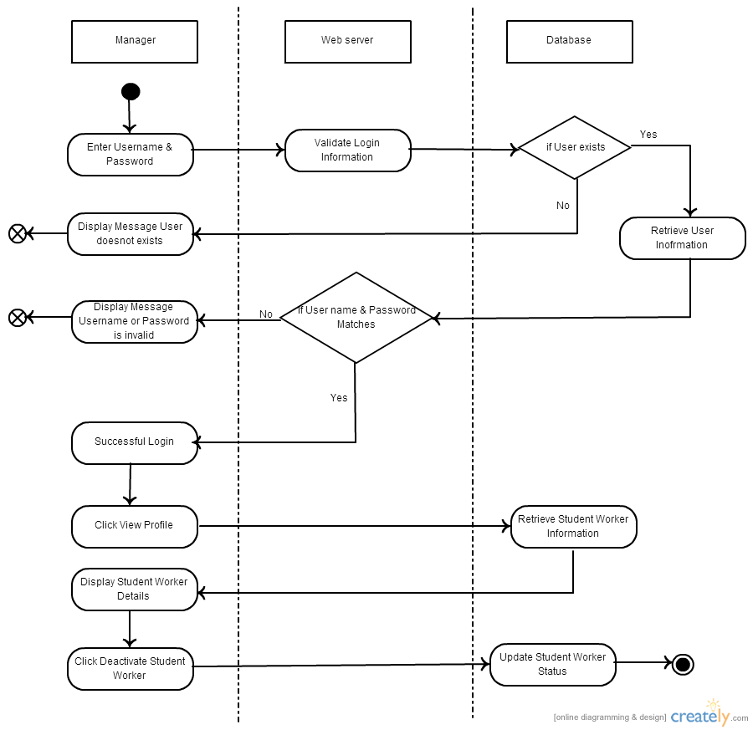

## Module 1– Login

### Activity Diagram 5 – Login

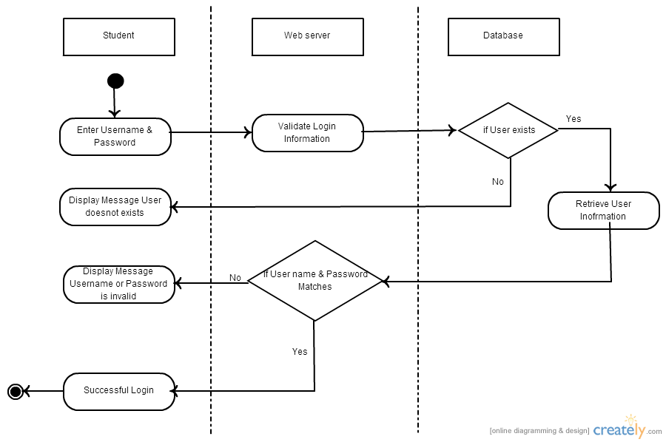

### Activity Diagram 6 – Change password

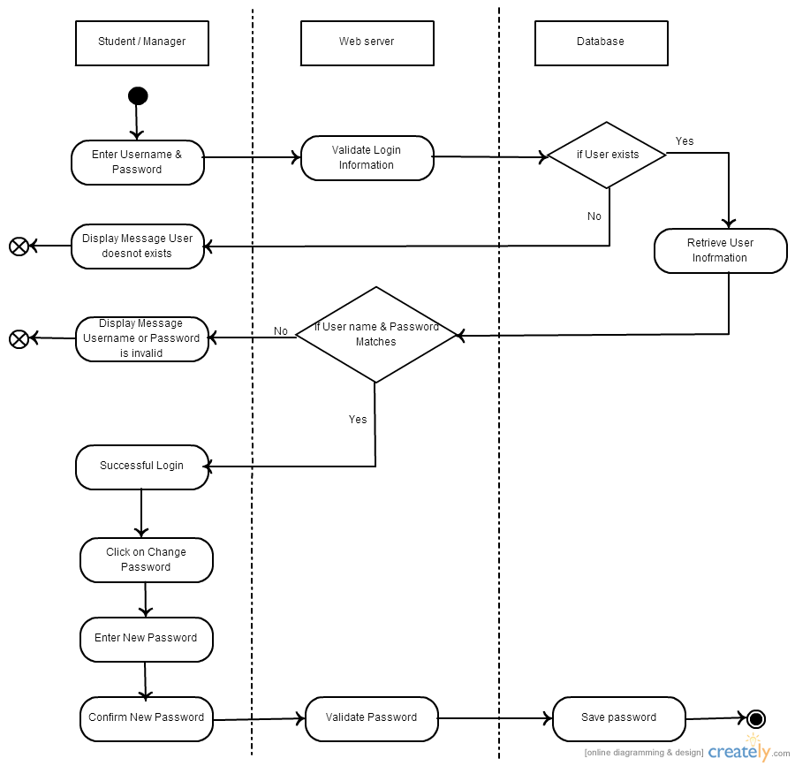

### Activity Diagram 7 – Forget Passowrd

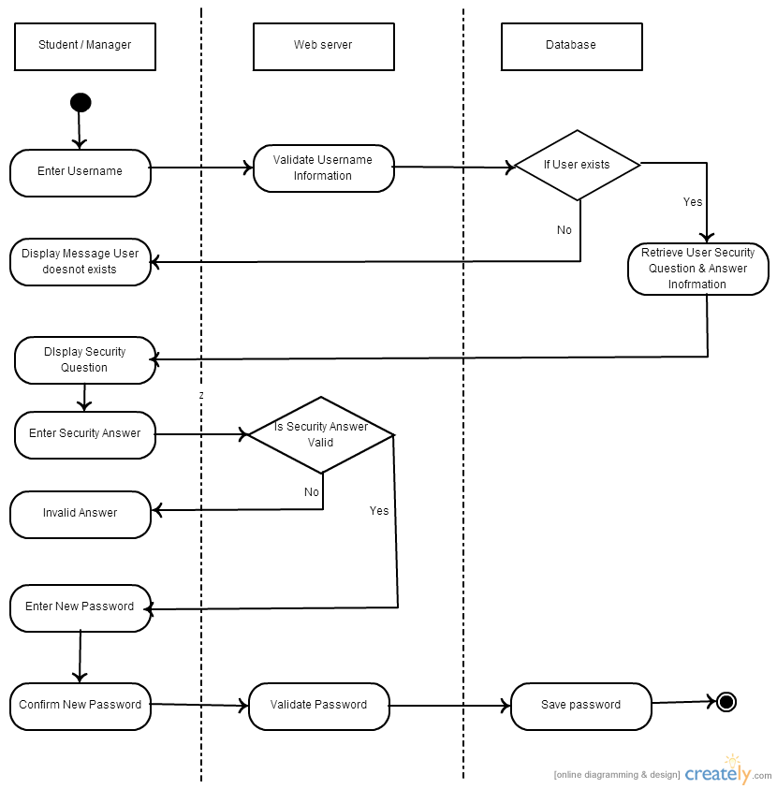

## Module 2 and 4 –Timesheet

### Activity Diagram 8– Timesheet

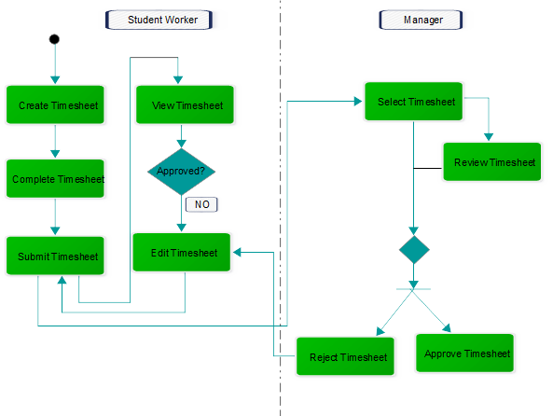

## Module 3- Leave Management

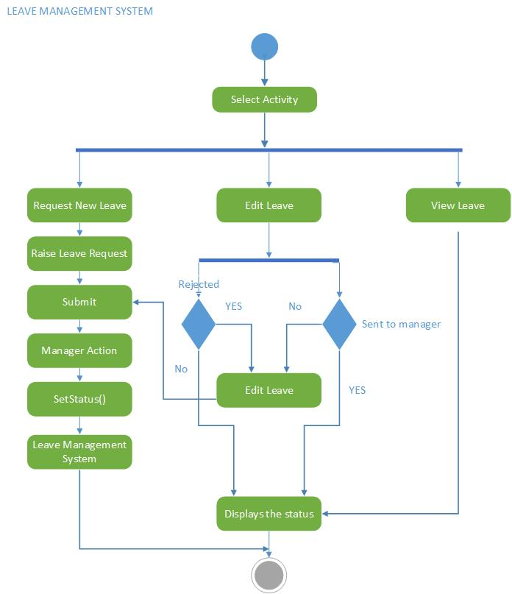

## Module 5 – Approve/Reject Leave Requests

### Activity Diagram 8 – Approve Leave Request

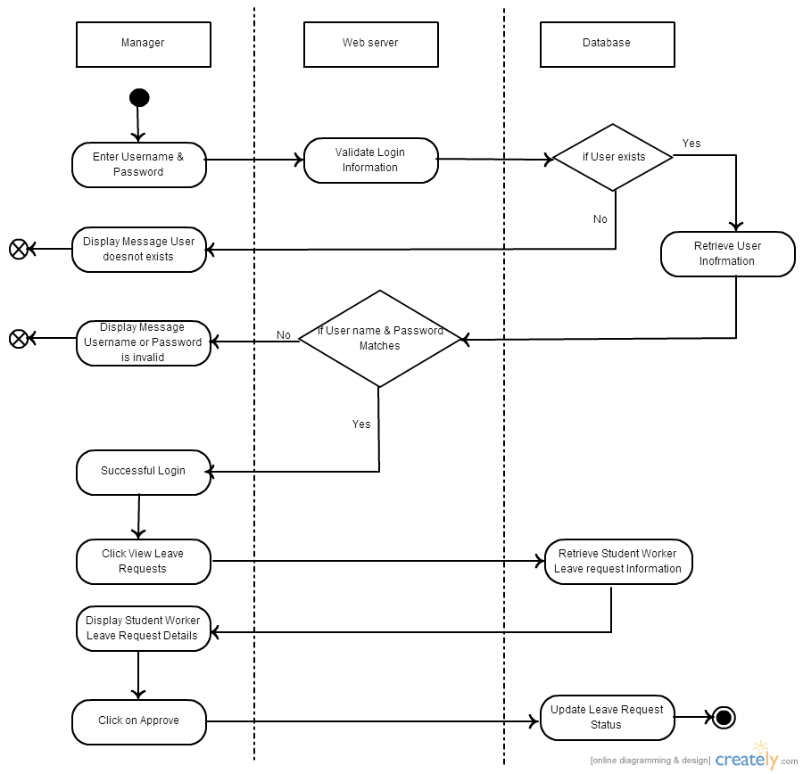

### Activity Diagram 9 – Reject Leave Request

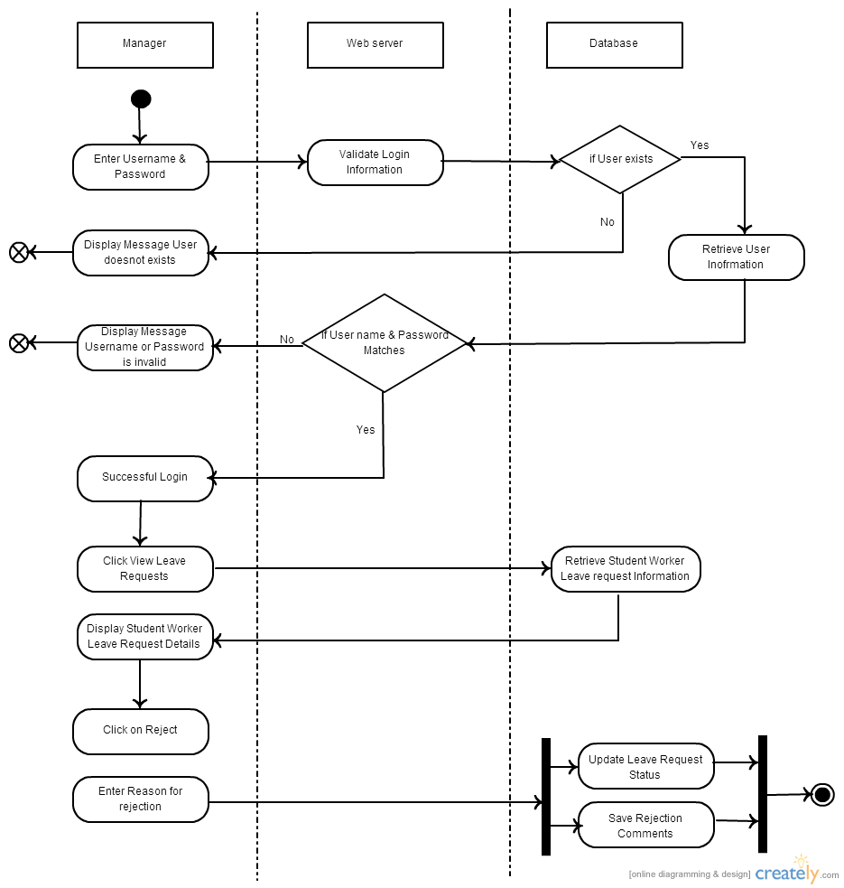

# Sequence Diagrams

## Module 0 – Student worker Profile

### Sequence Diagram 0 – Manger

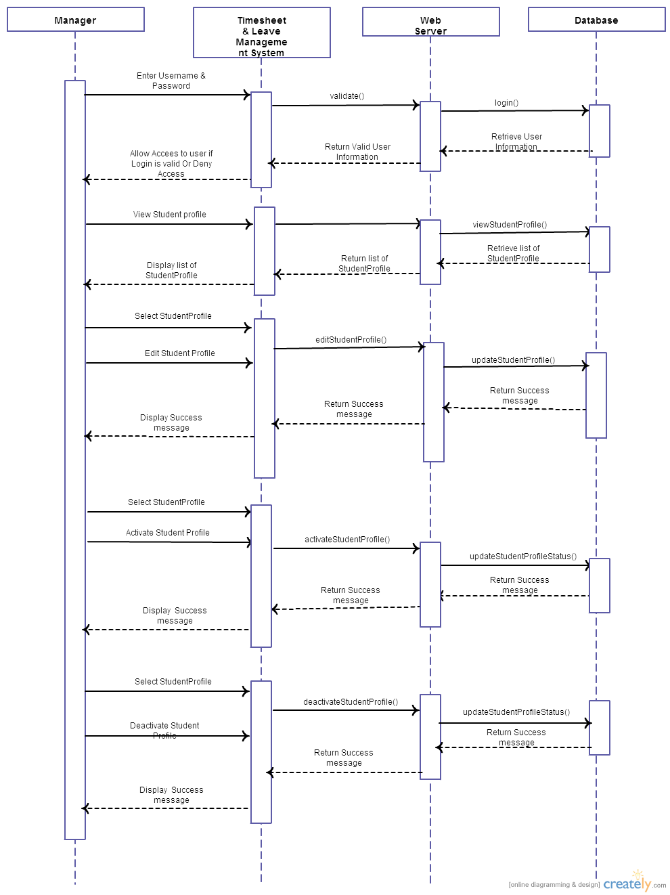

### Sequence Diagram 1 – Student

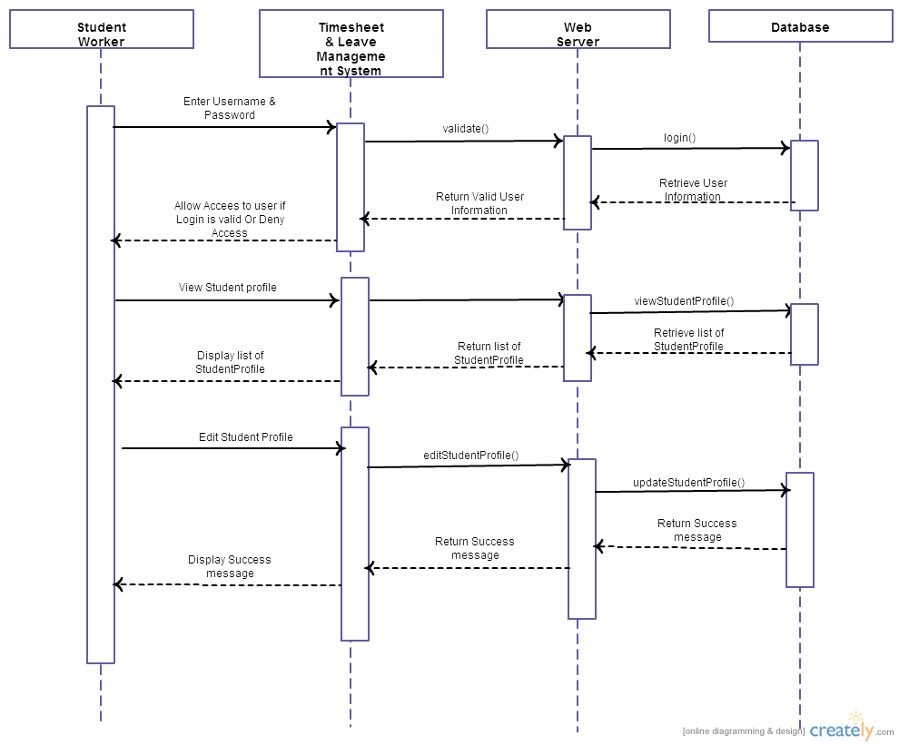

## Module 1 – Login

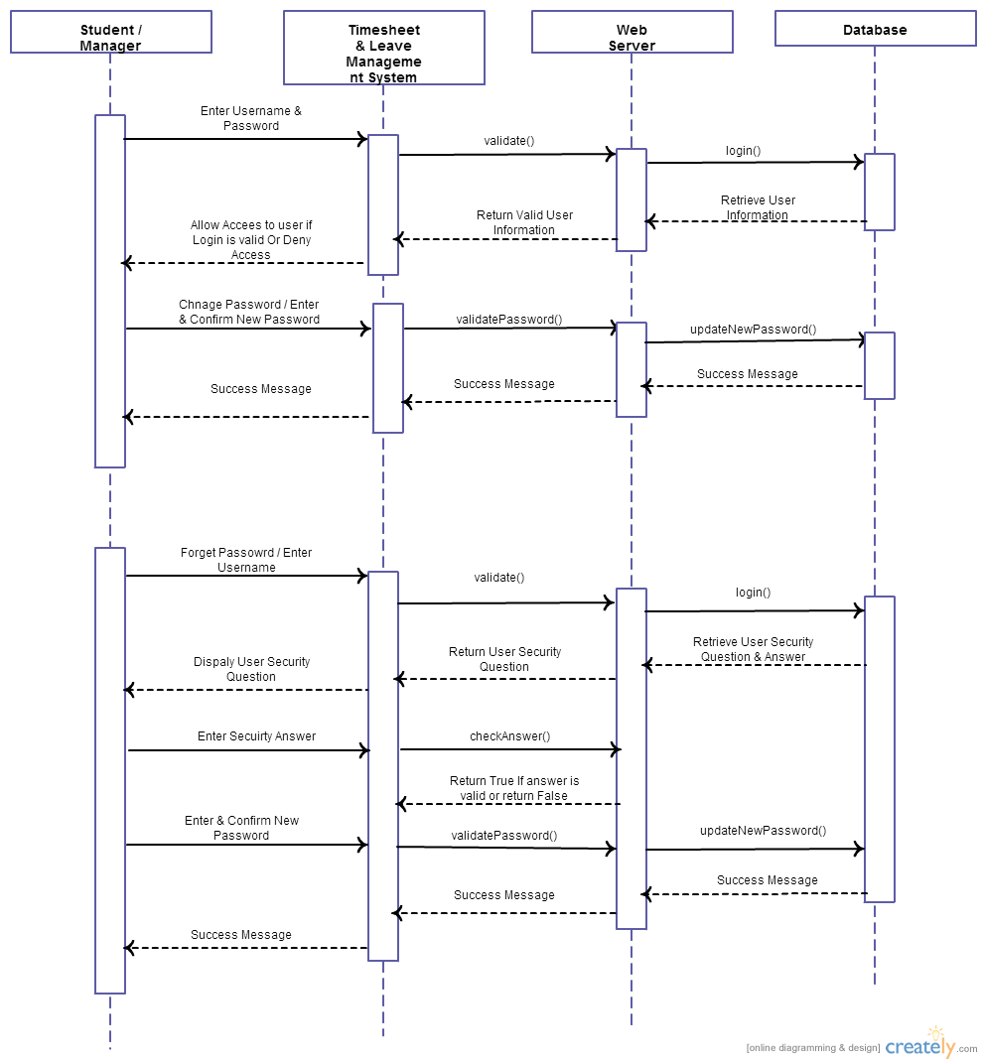

## Module 2 & 4 – Timesheets

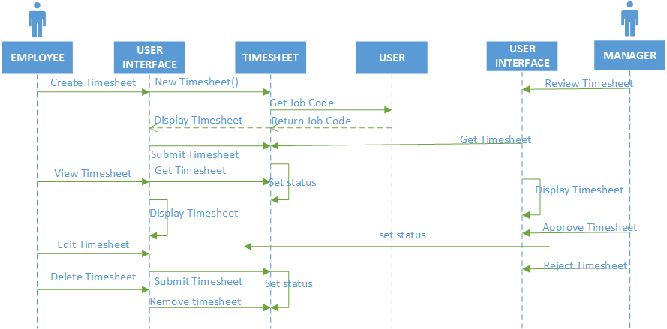

## Module 3- Leave Management

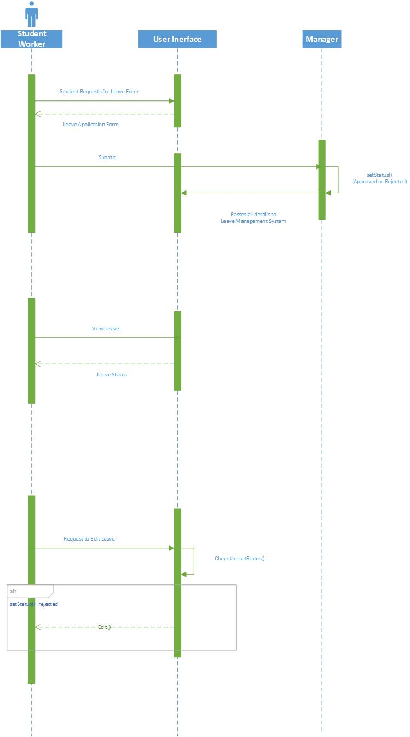

## Module 5 – Approve/Reject Leave Requests

